Agricultural Revolution and beyond!
DO everything in ORDER and the map is LAST

WATCH the Last Ice Age (posted on my website) and work with a partner to answer these questions:
Domestication of ANIMALS –  Name the eleven animals he mentions below |  | Domestication of PLANTS –work with your group to name what they grew…
He calls the raising of animals a fancy word…what is that word? P |  | What job raises these PLANTS?
What job is it to lead these animals around?

WATCH next video: Neolithic Agricultural Revolution
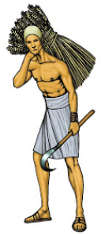
Modern humans have been around for about years…bigger , finer
Nomads (hunter gatherers) | Settled agriculture
Must food | food
Must often | How do they live?
Can only what you can | Grow a which is
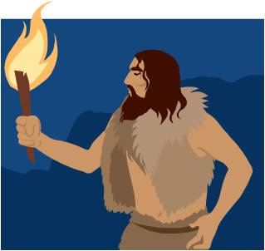  Mainly eat which is | They eat very little meat lots of
 | Able to lots of food
What do they do in times of DROUGHT? (dry, not a lot of rain)

MORE FOOD = ... DIVISION OF
Labor = jobs…what jobs does he mention?
The more surplus, the more T you have…This is called a POSITIVE
Today feeds thousands and the world’s population is over

Compare these two to see how the world changed…
 | Barbarian Warrior | Roman Soldier
Diet (nutritious?)
Physical appearance
Population
JOB TITLE -

Watch the next Video: Villages to Cities
The fertile land they talk about? What rivers?
Name several jobs Uruk the farmer must do:
Most of all your in constant danger of by
So they form a to band together for and work becomes
About 4,000 BCE, Uruk emerges as the first & the next 1000 years becomes the
Uruk was home to people. They did have new problems like
Use the ATLAS to Label and color these BLUE on the map below
- Persian Gulf
- Mediterranean Sea
- Tigris River & Euphrates River

Label and color these GREEN: Mesopotamia

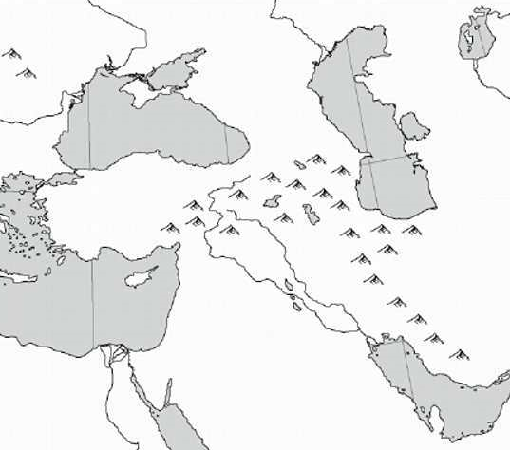
Just label these:
- Anatolia (hint – here it is)
- Taurus Mountains
- Catal Huyuk
- Syrian Desert
- Jericho

Now fill out these dates from our
Textbook or the atlas in class
9000 B.C.

8000 B.C.

