Chapter 5, lessons 2.1 and 2.2 Number Name
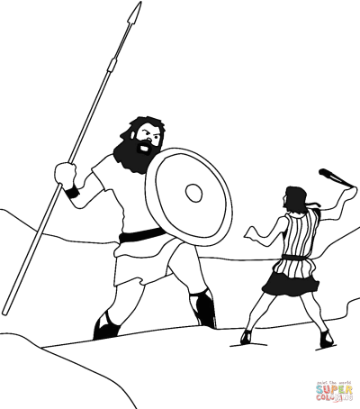
Start on age 132

- Describe David using the blurb on the right side of the page:
- 1020 B.C. the Jews appointed a KING named to fight the
- When he died the next king was and he
- He captured the city of and made it
- David’s son inherited a
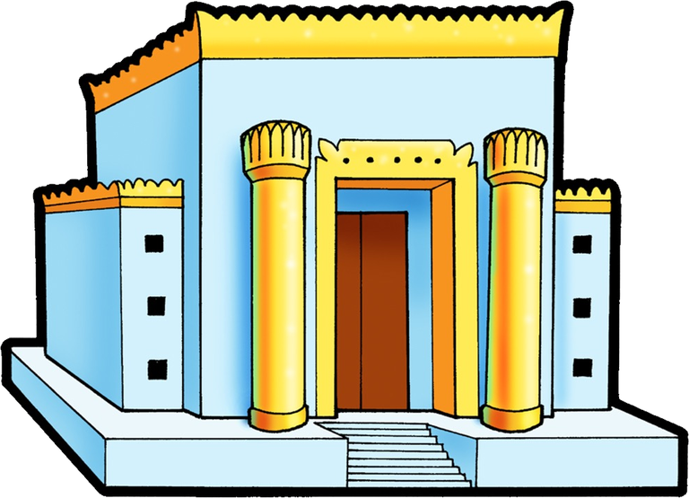
- He built
- Solomon used
- Most of the tax burden was on
- Once again,
- Soon war broke out
- Around 922,
- Northern kingdom was made up of
- Southern kingdom was
- Eventually Judaism and the Jewish people would be called
- In 722,
- The ten tribes of Israel were and disappeared from history
- The tribe of survived and was able to fight off
- They were then between two warring groups, and
- The New Babylonian army led by overran
- Then, they rebelled. In 597 B.C. he responded by
- In 586 B.C. Nebuchadnezzar’s army
- For the Jews, the age of was over

BABYLONIAN CAPTIVITY
- The 50 years they were exiled was called the
- Define EXILE:
- This is when they first built
- Any tribal divisions was replaced by
- Scribes started writing down
- They found it possible to
- They held on to their
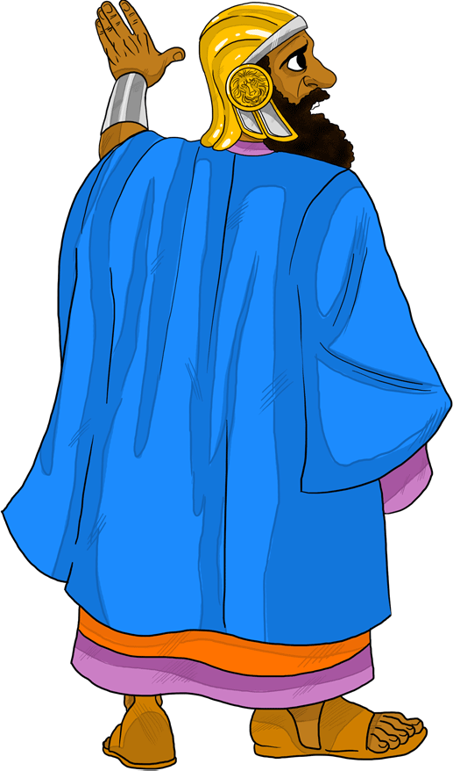
- Who was CYRUS the GREAT and what did he do?
- He adopted a policy of
- Because of this Cyrus became a
- In 538 B.C.
- There they began rebuilding
- In particular they finalized the which became the
- Color these if time
