DBQ Instructions:
Read these instructions before you read the passages on the back side. VERY IMPORTANT!
- Read with your pencil in hand
- Read the passage again aloud
- I want you to ANNOTATE the passage but don’t circle or highlight the whole thing!!!!!
  - Write a STAR where you see the main point
  - Place a QUESTION MARK next to words you don’t know
  - CIRCLE important phrases
- Ask yourself WHAT IS THE TEXT DOING, what does it mean!!!!!!
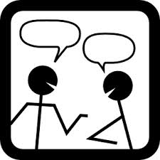
What to do after answering the questions:
- You will pair up with the person next to you
- Both stand up facing each other, one listening and one speaking
- Take turns explaining what you just read to your partner, WITHOUT YOUR PAPER!
- Each person gets 2 minutes to explain, while the other is listening
- Then, you will write down what you learned from your partner below

