SPRITE GAL Review on Egypt – list at least 3 facts for each section state the BIG idea! (most important)
Society  page 157 | BIG IDEA?
Political (Government)  page 165 & lesson 4 | BIG IDEA?
Religion  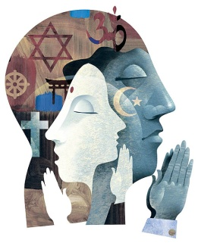page 159 | BIG IDEA?
Intellectual  (education)  page 158 | BIG IDEA?
Technology  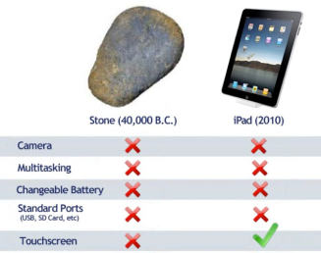  page 148-151, 158 | BIG IDEA?

Economy (trade/ agriculture)  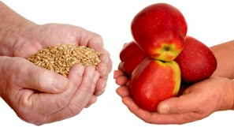  Page 148 & 151 | BIG IDEA?
Geography  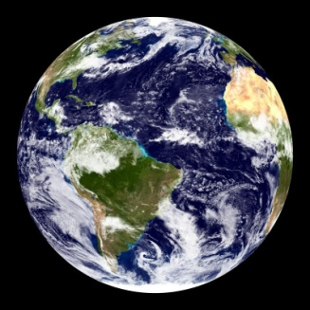  Lesson 1 | BIG IDEA?
Art/ Architecture  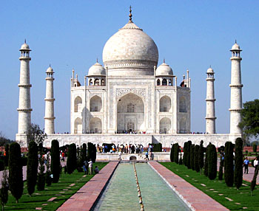  Lesson 2 & page 175 | BIG IDEA?
Language  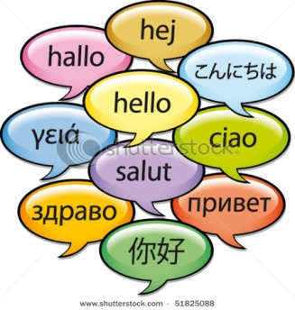  page 158 | BIG IDEA?

